Chapter 9, Problem 27.

A parallel RLC circuit has the node equation

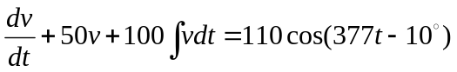

Determine v(t) using the phasor method. You may assume that the value of the integral at t = -∞ is zero.

